In this video we will discuss implementing new user registration page. This is continuation to [Part 20](http://csharp-video-tutorials.blogspot.com/2016/11/aspnet-web-api-token-authentication.html). Please watch [Part 20](http://csharp-video-tutorials.blogspot.com/2016/11/aspnet-web-api-token-authentication.html) from [ASP.NET Web API tutorial](https://www.youtube.com/playlist?list=PL6n9fhu94yhW7yoUOGNOfHurUE6bpOO2b) before proceeding.   
  
  
  
The registration page should be as shown below.   
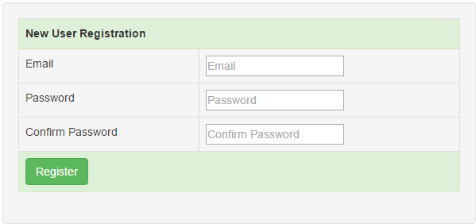  
  
  
  
**For a new user to register they have to provide**  
1. Email address  
2. Password   
3. Confirm password   
  
When all the fields are provided and when the Register button is clicked, the new user details should be saved and a modal dialog should be displayed as shown below.   
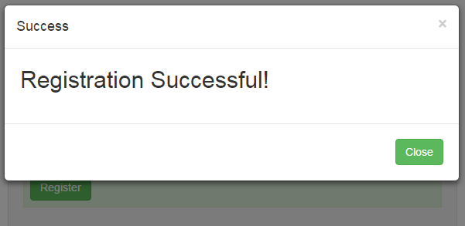  
  
To achieve this, add an HTML page to EmployeeService project. Name it Register.html. Copy and paste the following HTML and jQuery code.

<!DOCTYPE html>

<html>

<head>

    <title></title>

    <meta charset="utf-8" />

    <link href="Content/bootstrap.min.css" rel="stylesheet" />

</head>

<body style="padding-top:20px">

    <div class="col-md-10 col-md-offset-1">

        <div class="well">

            <!--This table contains the fields that we want to capture to register a new user-->

            <table class="table table-bordered">

                <thead>

                    <tr class="success">

                        <th colspan="2">

                            New User Registration

                        </th>

                    </tr>

                </thead>

                <tbody>

                    <tr>

                        <td>Email</td>

                        <td><input type="text" id="txtEmail" placeholder="Email" /> </td>

                    </tr>

                    <tr>

                        <td>Password</td>

                        <td><input type="password" id="txtPassword"

                                   placeholder="Password" /></td>

                    </tr>

                    <tr>

                        <td>Confirm Password</td>

                        <td><input type="password" id="txtConfirmPassword"

                                   placeholder="Confirm Password" /></td>

                    </tr>

                    <tr class="success">

                        <td colspan="2">

                            <input id="btnRegister" class="btn btn-success"

                                   type="button" value="Register" />

                        </td>

                    </tr>

                </tbody>

            </table>

            <!--Bootstrap modal dialog that shows up when regsitration is successful-->

            <div class="modal fade" tabindex="-1" id="successModal"

                 data-keyboard="false" data-backdrop="static">

                <div class="modal-dialog modal-sm">

                    <div class="modal-content">

                        <div class="modal-header">

                            <button type="button" class="close" data-dismiss="modal">

                                &times;

                            </button>

                            <h4 class="modal-title">Success</h4>

                        </div>

                        <div class="modal-body">

                            <form>

                                <h2 class="modal-title">Registration Successful!</h2>

                            </form>

                        </div>

                        <div class="modal-footer">

                            <button type="button" class="btn btn-success"

                                    data-dismiss="modal">

                                Close

                            </button>

                        </div>

                    </div>

                </div>

            </div>

            <!--Bootstrap alert to display any validation errors-->

            <div id="divError" class="alert alert-danger collapse">

                <a id="linkClose" href="#" class="close">&times;</a>

                <div id="divErrorText"></div>

            </div>

        </div>

    </div>

    <script src="Scripts/jquery-1.10.2.min.js"></script>

    <script src="Scripts/bootstrap.min.js"></script>

    <script type="text/javascript">

        $(document).ready(function () {

            //Close the bootstrap alert

            $('#linkClose').click(function () {

                $('#divError').hide('fade');

            });

            // Save the new user details

            $('#btnRegister').click(function () {

                $.ajax({

                    url: '/api/account/register',

                    method: 'POST',

                    data: {

                        email: $('#txtEmail').val(),

                        password: $('#txtPassword').val(),

                        confirmPassword: $('#txtConfirmPassword').val()

                    },

                    success: function () {

                        $('#successModal').modal('show');

                    },

                    error: function (jqXHR) {

                        $('#divErrorText').text(jqXHR.responseText);

                        $('#divError').show('fade');

                    }

                });

            });

        });

    </script>

</body>

</html>

**Please note :**  
1. The ajax() method posts the data to '/api/account/register'  
2. You will find the Register() method in AccountController in Controllers folder  
3. AccountController is provided by ASP.NET Web API, which saves data to a local membership database  
  
In our next video we will discuss where the users registration data is stored and all the customizations that can be made.